Original Article

Etiology and Antimicrobial Susceptibility Pattern of Bacterial Keratitis at a Tertiary Care Hospital

Fahd Kamal Akhtar, Zubair Saleem, Muna Malik, Adeel Chaudhary, Ayesha Sajjad, Abdul Mudabbir Rehan

Pak J Ophthalmol 2019, Vol. 35, No. 4
. . . . . . . . . . . . . . . . . . . . . . . . . . . . . . . . . . . . . . . . . . . . . . . . . . . . . . . . . . . . .. . .. . . . . . . . . . . . . . . . . . . . . . . . . . . . . . . . . . . . .
See end of article for  authors affiliations  …..………………………..  Correspondence to:  Dr. Muna Malik  Department of Pathology  LGH, Lahore  Email: mmkamboh@hotmail.com  …..……………………….. | Purpose: To find out the etiology and antimicrobial susceptibility pattern of bacterial keratitis at a tertiary care hospital in Lahore.  Study Design: Descriptive cross sectional study.  Place and Duration of Study: Postgraduate Medical Institute/Ameer ud Din Medical College /Lahore General Hospital, Lahore, from 2015 – 2018.  Material and Methods: Clinically suspected patients of bacterial keratitis were selected from out patient department of Lahore General hospital and corneal scrapings were collected before start of antimicrobial therapy. Patients who were already on antimicrobial therapy and patients with suspected keratitis caused by micro-organism other than bacteria were excluded from the study. The corneal scrapings taken by the ophthalmologist were immediately inoculated on different culture plates with the help of sterilized wire loop in the operation theater. These plates were taken to the laboratory for incubation and further microbiological processing. The scrapings from cornea were also smeared on glass slides with the help of sterilized wire loop for staining. The culture and staining were further processed for microbiological analysis of bacterial etiology and antimicrobial susceptibility.  Results: A total of 65 corneal scrapings were done out of which 25 were positive for bacterial growth. Seven cases were positive for Staphylococcus and Streptococcus pneumoniae species each, 5 were Pseudomonas, 3 were Klebsiella, 2 were Acinetobacotar & one was Nocardia. Gram negative bacteria were relatively more sensitive to all groups of antibiotics as compared to Gram positive bacteria.  Conclusion: Staphylococcus and Streptococcus pneumoniae species are the commonest cause of bacterial keratitis in our setup.  Key words: Bacterial keratitis, Pseudomonas, culture, gram staining.

Bacterial keratitis accounts for about 90% of all reported infective keratitis cases¹. Bacterial keratitis causes can cause severe corneal infection and is one of the leading causes of visual loss². It usually progresses when the ocular defense has been compromised either by trauma, contact lens or ocular surface diseases³.
Development of bacterial keratitis is speedy, so need of the hour is to treat it as a medical emergencyand treatment should be initiated promptly with empirical antibiotics⁴. However, if this infection is left untreated it may end up in corneal perforation, endophthalmitis and permanent visual loss⁵. The prompt diagnosis of the causative organism can be done by performing culture. Cultures also provide evidence about antibiotic sensitivity and information regarding prognosis of the disease⁶.
Gram-positive cocci like Staphylococcus species and Streptococcus pneumonia are the commonest bacterial pathogens causing infective keratitis⁷. Among Gram-negative-bacteria, Pseudomonas species is the most common cause, other Gram-negative bacteria are Escherichia coli, Proteus species and Klebsiella pneumonia^{5,8}.
When bacterial flora gain access in immune-compromised eye due to trauma, eye surgery, usage of contact lens or any other eye infections, it leads to corneal infection⁹. Different bacteria have different virulence factors for adhesion and pathogenesis and they will help them in causing keratitis. Lipopolysaccharides of Gram-negative bacteria play an important role as a virulent agent in infectious keratitis¹⁰. The proteases cleave collagen of the corneal stromal tissue and hence they cause obliteration of cornea¹¹. The strength of this inflammatory response and the damage associated with it is variable depending on the pathogenic microorganisms and the severity of infection they cause¹².
For ophthalmologists bacterial culture is crucial in determining the pathogens of keratitis, as clinical appearance of infection sometimes appears to be unreliable. Thus, the purpose of the study was to isolate bacterial etiology of infective keratitis and its antimicrobial susceptibility pattern in Pakistan. This will facilitate clinicians in our setup for diagnosis of infective keratitis and its treatment.

MATERIAL AND METHODS
This study was conducted in the Ophthalmology Department of Lahore General hospital, Lahore from 2015 to 2018. Institutional review board approved the study. The clinically suspected patients of Infective keratitis were selected and corneal scrapings were collected before start of antimicrobial therapy. Patients who were already on antimicrobial therapy and patients with suspected keratitis caused by micro-organism other than bacteria were excluded from the study. Corneal scrapings were collected from 65 patients by ophthalmologist in operation theater of Eye department, Lahore General Hospital, Lahore. The patient’s name, sex, age, date of collection, brief clinical history including onset, history of trauma/ corneal foreign body, duration and any other corneal problems were asked and recorded. Xylociane was instilled in the eye to anesthetize the cornea. The necrotic tissue and loose mucus was detached from the surface of the ulcer. The margins and base of the ulcer were scraped by disposable scalpel blade no 15.
Corneal scrapings taken by the ophthalmologist were immediately inoculated on Chocolate agar, Blood agar and MacConkay agar culture plates with the help of sterilized wire loop in the operation theater. These plates were taken to laboratory for incubation and further microbiological processing.
Chocolate Agar was used for isolation of fastidious bacteria particularly H. influenza, Neisseria spp. and Moraxella spp. The agar plates were incubated in carbon dioxide (CO₂) enriched atmosphere in candle jar at 37˚C for 24 hours. Blood Agar was used for isolation of non-fastidious bacteria. The plates were incubated aerobically at 37˚C for 24 hours. Any growth on culture agar plate was assessed visually. The cultural characteristics of individual colonies like size, shape, surface, color, consistency, elevation, pigment production, presence or absence of hemolysis was noted on blood agar. Staphylococcus aureus and Streptococcus pneumonia were the commonest bacteria. Macconkay Agar was used for isolation of Gram-negative bacteria. The plates were incubated aerobically at 37˚C for 24 hours. Any growth on culture plate was assessed visually for, lactose fermenters and non-fermenters. Most commonly isolated Gram-negative bacterium was Pseudomonas spp. The identified bacteria were tested for their antimicrobial susceptibility pattern according to Clinical and Laboratory standards institute (CLSI).
After inoculating on the culture agar plates, the scrapings from cornea were smeared on glass slides with the help of sterilized wire loop. The smears were air-dried, stained with Gram’s stain, Kinyoun stain and Giemsa stain. Grams staining was used to identify Gram positive and Gram-negative bacteria. Giemsa was used to see the inclusion bodies of Chlamydia trachomatis in infected epithelial cells. Bacteria was stained dark blue bacilli or cocci. Inflammatory cells were differentiated into mononuclear and polymorphs cells. Kinyoun staining was used for identification of Nocardia spp. It appeared as weak acid fast branching filaments. They also stained as Gram-positive branching filaments.

RESULTS
In our study, total 65 corneal scrapings were done. Out of these 65 samples only 25 were positive for bacterial growth culture. Out of 25, 7 were positive for growth of Staphylococcus spp, 7 were cases of Streptococcus pneumonia, 5 were Pseudomonas, 3 were Klebsiella, 2 were Acinetobacotar & one was Nocardia. were identified. Rest of the results are shown in figure 1, 2, 3 and table 1.

Fig. 1: Frequency of bacteria isolated from corneal scrapings.

Table 1: Cumulative antimicrobial susceptibility data of Klebsiella spp, Pseudomonas spp. and Acinetobacter spp. Isolated from patients of infective keratitis.

Antibiotics | % Age of Sensitivity
Antibiotics | Klebsiella spp.  N=3 | Pseudomonas spp.  N=5 | Acinetobacter  Spp. N=2
Amoxicillin-clavulanicacid 30µg | 70% | -- | --
Ceftazidime 30 µg | 90% | 90% | 70%
Cefotaxime 30 µg | 80% | -- | 70%
Ceftraiaxone 30 µg | 80% | -- | 70%
Cefepime 30 µg | 90% | 90% | 80%
Cefaperazone-salbactam | 100% | 100% | 100%
Sulphamethoxazole trimethoprim | 80% | -- | 80%
Gentamicin 10 µg | 100% | 90% | 100%
Tobramycin µg | 100% | 100% | 100%
Amikacin 30 µg | 100% | 100% | 100%
Ciprofloxacin 30 µg | 90% | 80% | 90%
Levofloxacin 30 | 90% | 90% | 90%
Imepenem | 100% | 100% | 100%
Meropenem | 100% | 100% | 100%
Pipercillin- tazobactam | 100% | 100% | 100%
Piperacillin | -- | 90% | 100%
Ampicillin- salbactam | -- | -- | 100%
Doxycyclin | 90% | 90% | 100%

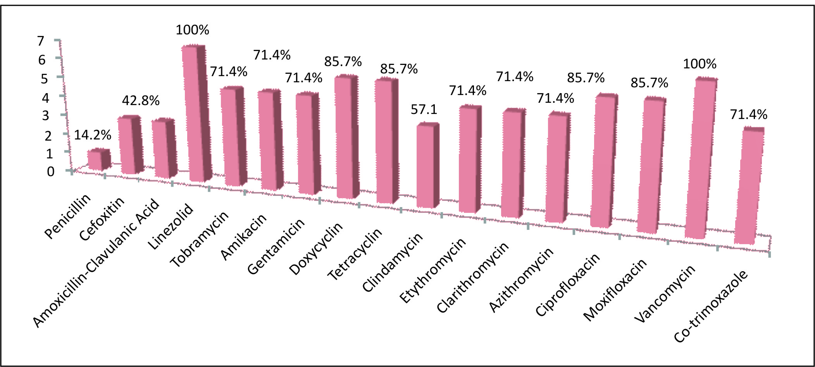

Fig. 2: Antimicrobial susceptibility pattern of Satphlylococcus spp isolated from corneal scrapings.

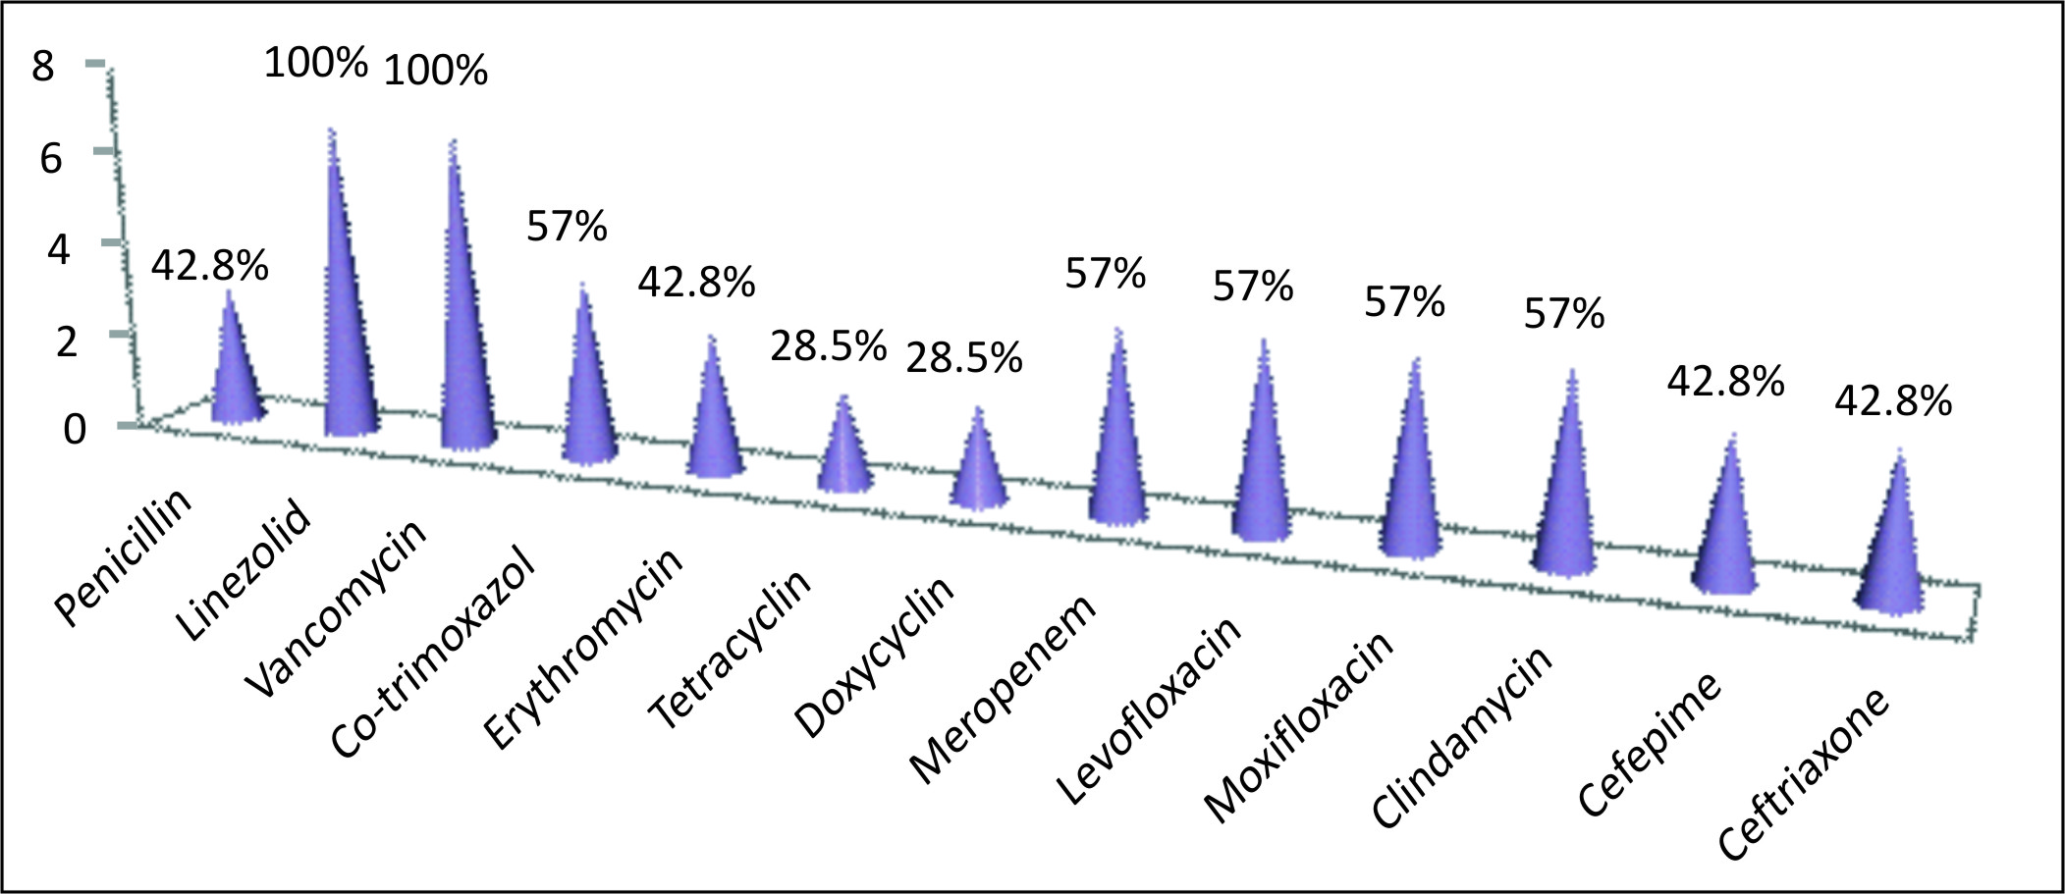

Fig. 3: Antimicrobial sensitivity of Streptococcus pneumoniae isolated from corneal scrapings.

DISCUSSION
In our present study we found spectrum of bacterial microrganisms which were isolated from the cultures of corneal scrapings at the microbiology laboratory of a tertiary care hospital. In our study the most frequent bacteria which were isolated from corneal scrapings were Staphylococcus aureus and streptococcus spp., which is similar to the studies conducted in Sans Francisco, which reported upto 45% of Staphylococcus aureus in their study¹³. Moreover, many studies on infective keratitis also reported Pseudomonas spp., Acinetobacter spp. and klebsiella spp. as pathogens of microbial keratitis, which is similar to our results¹⁰.
Antimicrobial resistance has turned out to be one of the chief community health extortions of the
21st century. In a so-called “post-antibiotic” era it has become mandatory for clinicians to be sensible in the use of antibiotics to treat infections. Nowadays a trend of resistance against commonly given empirical antibiotics for treating keratitis has been documented, which includes fluoroquinolones and fortified antibiotics, often a combination of a cephalosporin or glycopeptide and aminoglycoside (e.g. ceftazidime or vancomycin and tobramycin or gentamicin)^{14,15}.
In our study we observed relatively less resistance among gram negative bacteria against antimicrobial agents. Only 3rd generation cephalosporins showed 30% of resistance. While other groups of antimicrobial agents were upto 90% sensitive. It is good for prognosis of infective keratitis treatment, which is also similar to the study conducted by Tiawan, in which most of the Gram negative bacteria causing keratitis were sensitive to antibiotics¹⁶. These antimicrobial therapeutic agents are not only used to eradicate the causative bacteria but also used to prevent irreversible destruction caused by enzymes and toxins of bacteria. However, the resistance among Gram positive bacteria like Staphylococcus spp. and Sterptococcus spp. against fluoroquinolones and aminoglycosides was 30%. It is similar to the observation done in a Bangladeshi study on Antibiotic susceptibility pattern of bacteria isolated from corneal ulcer¹⁷. Streptococcus pneumoniae was relatively more resistant as compared to Staphlococcus species. However, in contrast to our study, a study conducted in Sydney reported no resistance in Streptococcus pneumoniae isolated from corneal scrapings.¹⁸ Melbourne therapeutic guidelines showed no role of Oral or intravenous antibiotics in the management of uncomplicated bacterial keratitis¹⁹. However, it should be kept in mind that susceptibility patterns change according to climate and geographical region and can fluctuate from time to time²⁰.
In our study we were limited to further investigate the susceptibility pattern changes according to the climate and geographical variation from time to time.

CONCLUSION
Staphylococcus and Streptococcus pneumoniae species are the commonest cause of bacterial keratitis in our setup.

Conflict of Interest
None.

REFERENCES
- Musa F, Tailor R, Gao A, Rauz S, Scott R. Contact lens-related microbial keratitis in deployed British military personnel. British J Ophthalmol. 2009: 161430.
- Hsiao CH, Sun CC, Yeh LK, Ma DH, Chen PY, Lin HC, et al. Shifting trends in bacterial keratitis in Taiwan: a 10-year review in a tertiary-care hospital. Cornea, 2016; 35 (3): 313-317.
- Shah A, Sachdev A, Coggon D, Hossain P. Geographic variations in microbial keratitis: an analysis of the peer-reviewed literature.British J Ophthalmol. 2011; 95 (6): 762-767.
- Gokhale NS. Medical management approach to infectious keratitis. Indian J Ophthalmo. 2008; 56 (3): 215.
- Wong RL, Gangwani R, Yu LW, Lai JS. New treatments for bacterial keratitis. J Ophthalmol. 2012; 2012: 831502.
- Bhadange Y, Das S, Kasav MK, Sahu SK, Sharma S. Comparison of culture-negative and culture-positive microbial keratitis: cause of culture negativity, clinical features and final outcome. British J Ophthalmol. 2015; 99 (11): 1498-1502.
- Marasini S, Swift S, Dean S, Ormonde S, Craig J. Spectrum and Sensitivity of Bacterial Keratitis Isolates in Auckland J Ophthalmol, 2016; 2016: 3769341.
- Shanthi J, Vanajapriya R, Balagurunathan R. Laboratory diagnosis and prevalence study of corneal infections from a tertiary eye care hospital. Advances in Applied Science Research, 2012; 3 (3): 1598-1602.
- Mohammadinia M, Rahmani S, Eslami G, Ghassemi-Broumand M, Amiri MA, Aghaie G, et al. Contact lens disinfecting solutions antibacterial efficacy: comparison between clinical isolates and the standard ISO ATCC strains of Pseudomonas aeruginosa and Staphylococcus aureus. Eye (Lond). 2012; 26 (2): 327-330.
- Lakhundi S, Siddiqui R, Khan NA. Pathogenesis of microbial keratitis. Microb Pathog. 2017; 104: 97-109.
- Tang A, Marquart ME, Fratkin JD, Mccormick CC, Caballero AR, Gatlin HP, et al. Properties of PASP: a Pseudomonas protease capable of mediating corneal erosions. Invest Ophthalmol Vis Sci. 2009; 50 (8): 3794-3801.
- Taube M, Del Mar Cendra M, Elsahn A,
- Christodoulides M, Hossain P. Pattern recognition receptors in microbial keratitis. Eye (Lond). 2015; 29 (11): 1399-1415.
- Peng MY, Cevallos V, McLeod SD, Lietman TM, Rose-Nussbaumer J. Bacterial Keratitis: Isolated Organisms and Antibiotic Resistance Patterns in San Francisco. Cornea, 2018; 37 (1): 84-7.
- Deorukhkarl S, Katiyarl R, Sainil S. Epidemiological features and laboratory results of bacterial and fungal keratitis: five-year study at tertiary-care hospital in western Maharashtra, India. Singapore Med J. 2012; 53 (4): 264-7.
- Ray KJ, Prajna L, Srinivasan M, Geetha M, Karpagam R, Glidden D, et al. Fluoroquinolone treatment and susceptibility of isolates from bacterial keratitis. JAMA Ophthalmology, 2013; 131 (3): 310-3.
- Hsiao CH, Sun CC, YehLK, Ma DH, Chen PY, Lin HC, et al. Shifting trends in bacterial keratitis in Taiwan: a 10-year review in a tertiary-care hospital. Cornea, 2016; 35 (3): 313-7.
- Nahar K, Islam MS. Antibiotic susceptibility pattern of bacteria isolated from corneal ulcer in a tertiary level eye hospital. Bangladesh Med. Res Counc Bull. 2014; 40 (3): 122-3.
- Watson S, Cabrera‐Aguas M, Khoo P, Pratama R, Gatus BJ, Gulholm T, et al. Keratitis antimicrobial resistance surveillance program, Sydney, Australia: 2016 Annual Report. Clin Exp Ophthalmol. 2019; 47 (1): 20-5.
- Antibiotic Expert Groups. Therapeutic guidelines: antibiotic. Version 15. Melbourne: Therapeutic Guidelines Limited, 2014.
- Asbell PA, Colby KA, Deng S, McDonnell P, Meisler DM, Raizman MB, et al. Ocular TRUST: nationwide antimicrobial susceptibility patterns in ocular isolates. Am J Ophthalmol. 2008; 145: 951–8.

Author’s Affiliation

Fahd Kamal Akhtar
Senior Registrar, Department of Ophthalmology, LGH, Lahore.

Zubair Saleem
Associate Professor of Ophthalmology, PGMI/AMC/ LGH, Lahore

Muna Malik
Assistant Professor of Pathology, PGMI/AMC/LGH, Lahore

Adeel Chaudhary
Senior registrar, Department of Ophthalmology, LGH, Lahore

Ayesha Sajjad
Assistant Professor of Pathology, Amna Inayat Medical College, Lahore

Author’s Contribution

Fahd Kamal Akhtar
Data acquisition and analysis, manuscript writing and final review.

Zubair Saleem
Data acquisition and analysis, manuscript writing and final review.

Muna Malik
Data acquisition and analysis, manuscript writing and final review.

Adeel Chaudhary
Data acquisition and analysis, manuscript writing and final review.

Ayesha Sajjad
Data acquisition and analysis, manuscript writing and final review.

